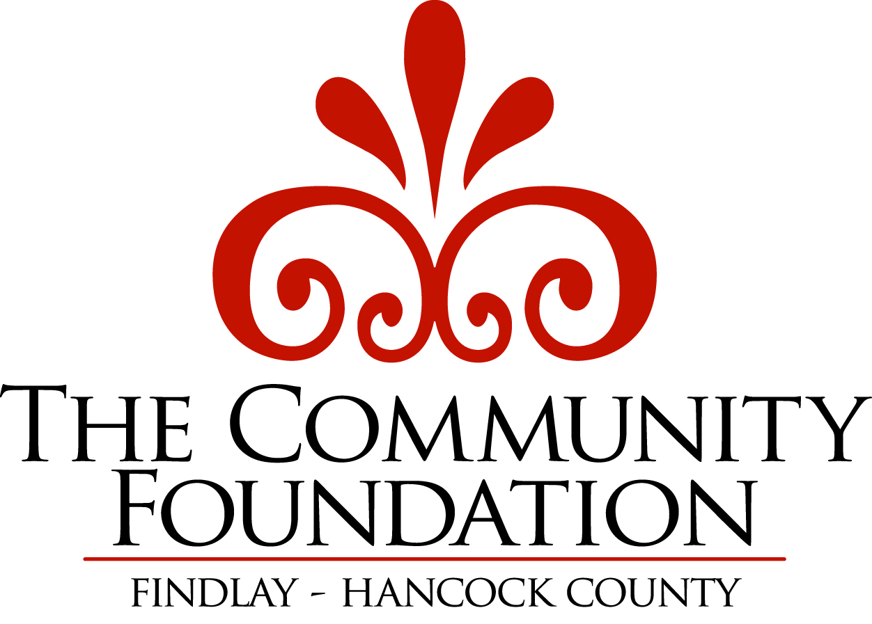
HANCOCK EDUCATION FUND
Grant Application Form

Due Date: First Friday of March

Please download or save this file to your computer. This document is a Microsoft Word document with form fields. Please type your application information where the grey shaded boxes appear. When your application form is completed, please email it to our office at kbash@community-foundation.com. You must also mail or hand-deliver a signed copy to our office along with the following documents:
- IRS tax exempt letter
- Non-discrimination statement
- Most recent financial audit
- Most recent annual report
- Current board list

Please select the type of grant for which you are applying:
TEACHER GRANT - Up to $2,000. Single classroom.

SCHOOL GRANT - Up to $4,000. Multiple classrooms in one building.

COLLABORATIVE GRANT - Up to $6,000. Multiple buildings in one or many districts.

APPLICANT INFORMATION:
Date:
Project Title:
Number of students served by this project:
Grade:
Applicant/Contact Person:
Position:
Daytime Phone Number:
Email Address:
School Building:
School Address:
Total Project Budget:
Amount Requested:
Has this project been funded by the Hancock Education Fund previously? |  | Yes No
If yes, when?
Please explain why requesting additional funds?
You should review the Hancock Education Fund Grant Application Guidelines and Evaluation Criteria prior to completing the section below.

GRANT PROPOSAL DETAIL:
1. STATEMENT OF NEED: (Why is this project needed? How will this project benefit students?)

2. DESCRIPTION OF PROJECT:

3. GOAL(S) OF THIS PROJECT: (purpose to be achieved by project).

4. OBJECTIVES: (A specific measurable outcome of the project – defining what will be
measured.)

5. TIMETABLE/PROCEDURES: (Sequential listing of major steps.)

6. BUDGET: (Specific itemized list of costs. Please indicate other sources of funding (both cash and in-kind) This grant requires a minimum of a 30% funding match (at least 15% cash and 15% in-kind).)

7. PLAN FOR EVALUATION OF PROJECT: (How will you determine if your project was
successful? How will you measure your results?)

Applicant’s Signature:
 | Signature Date
Building Principal’s Signature:
 | Signature Date

QUESTIONS? Please contact:
Kimberly Bash, Senior Program Officer
The Community Foundation
101 W. Sandusky St., Suite 207
Findlay, OH 45840
419-425-1100
kbash@community-foundation.com

